**Figure D**. The Geographical maps of the HPV Vaccination Rate on Long Island among 9- to 13-year-old kids in zip code level. The rate was calculated by the number of kids who already initialized the HPV vaccination divided by the number of kids either receive the HPV vaccination or Tdap vaccination.

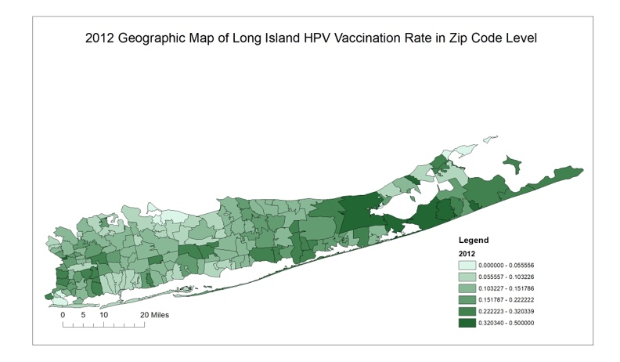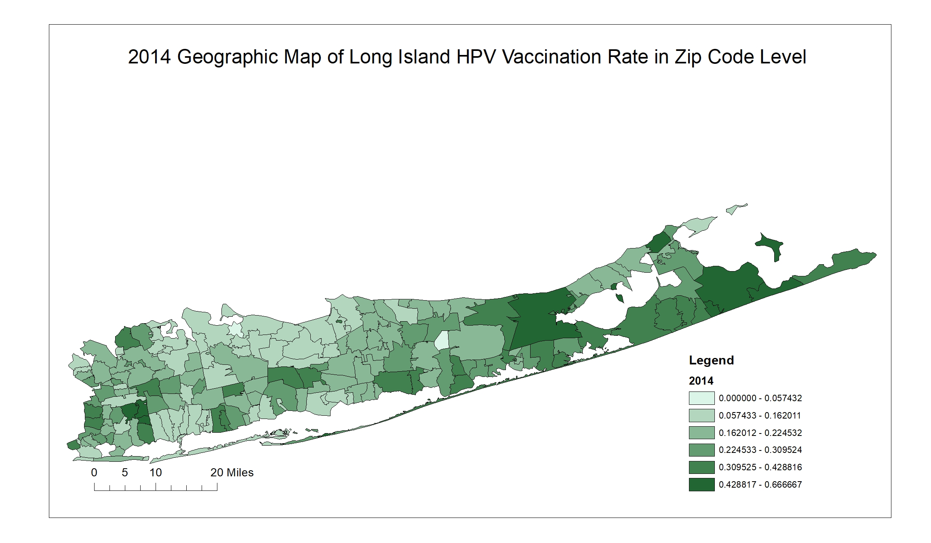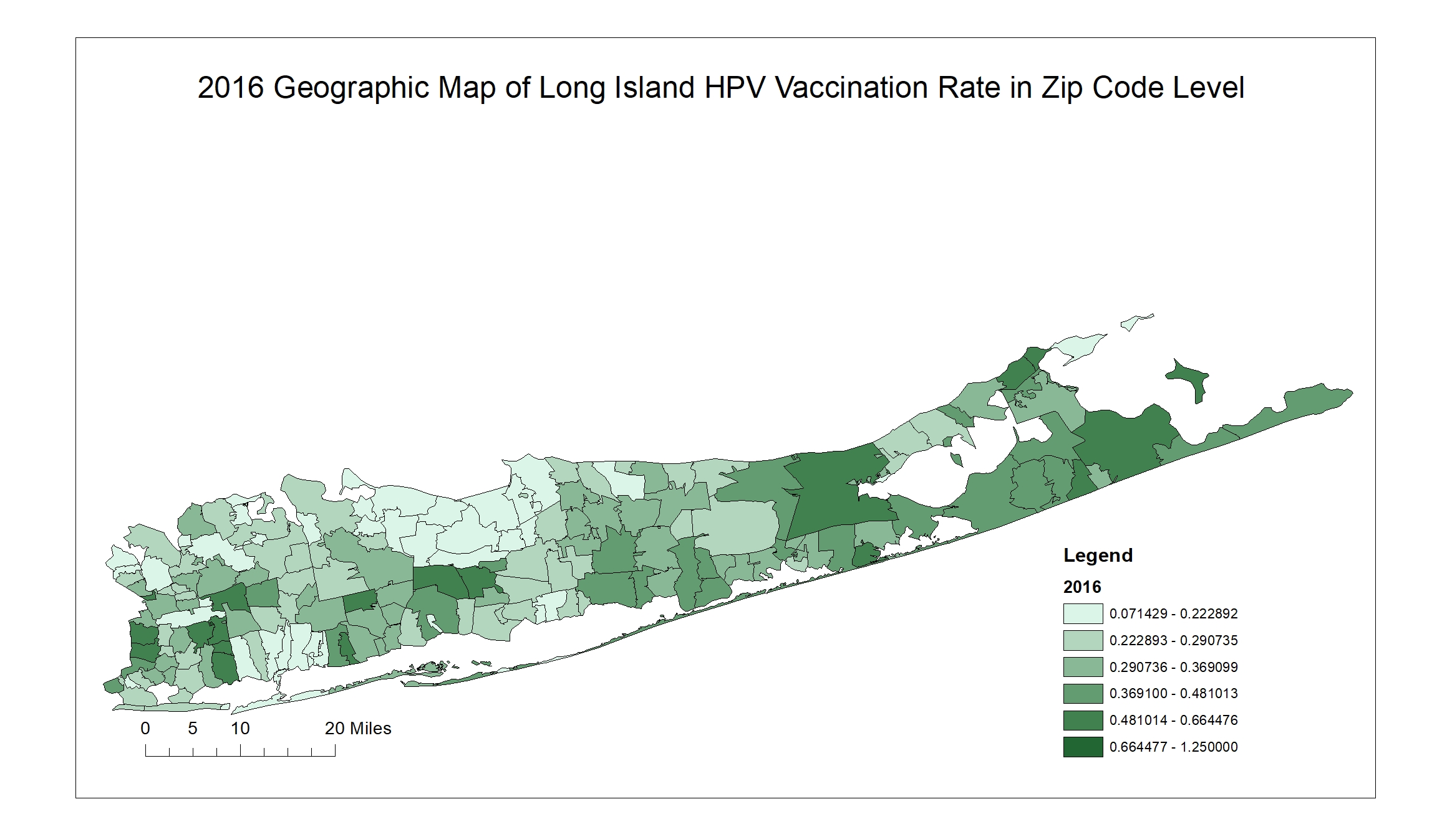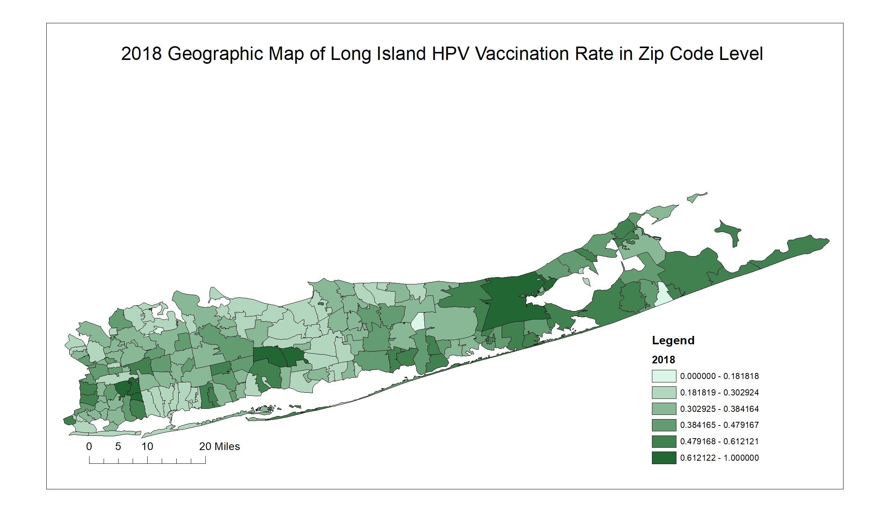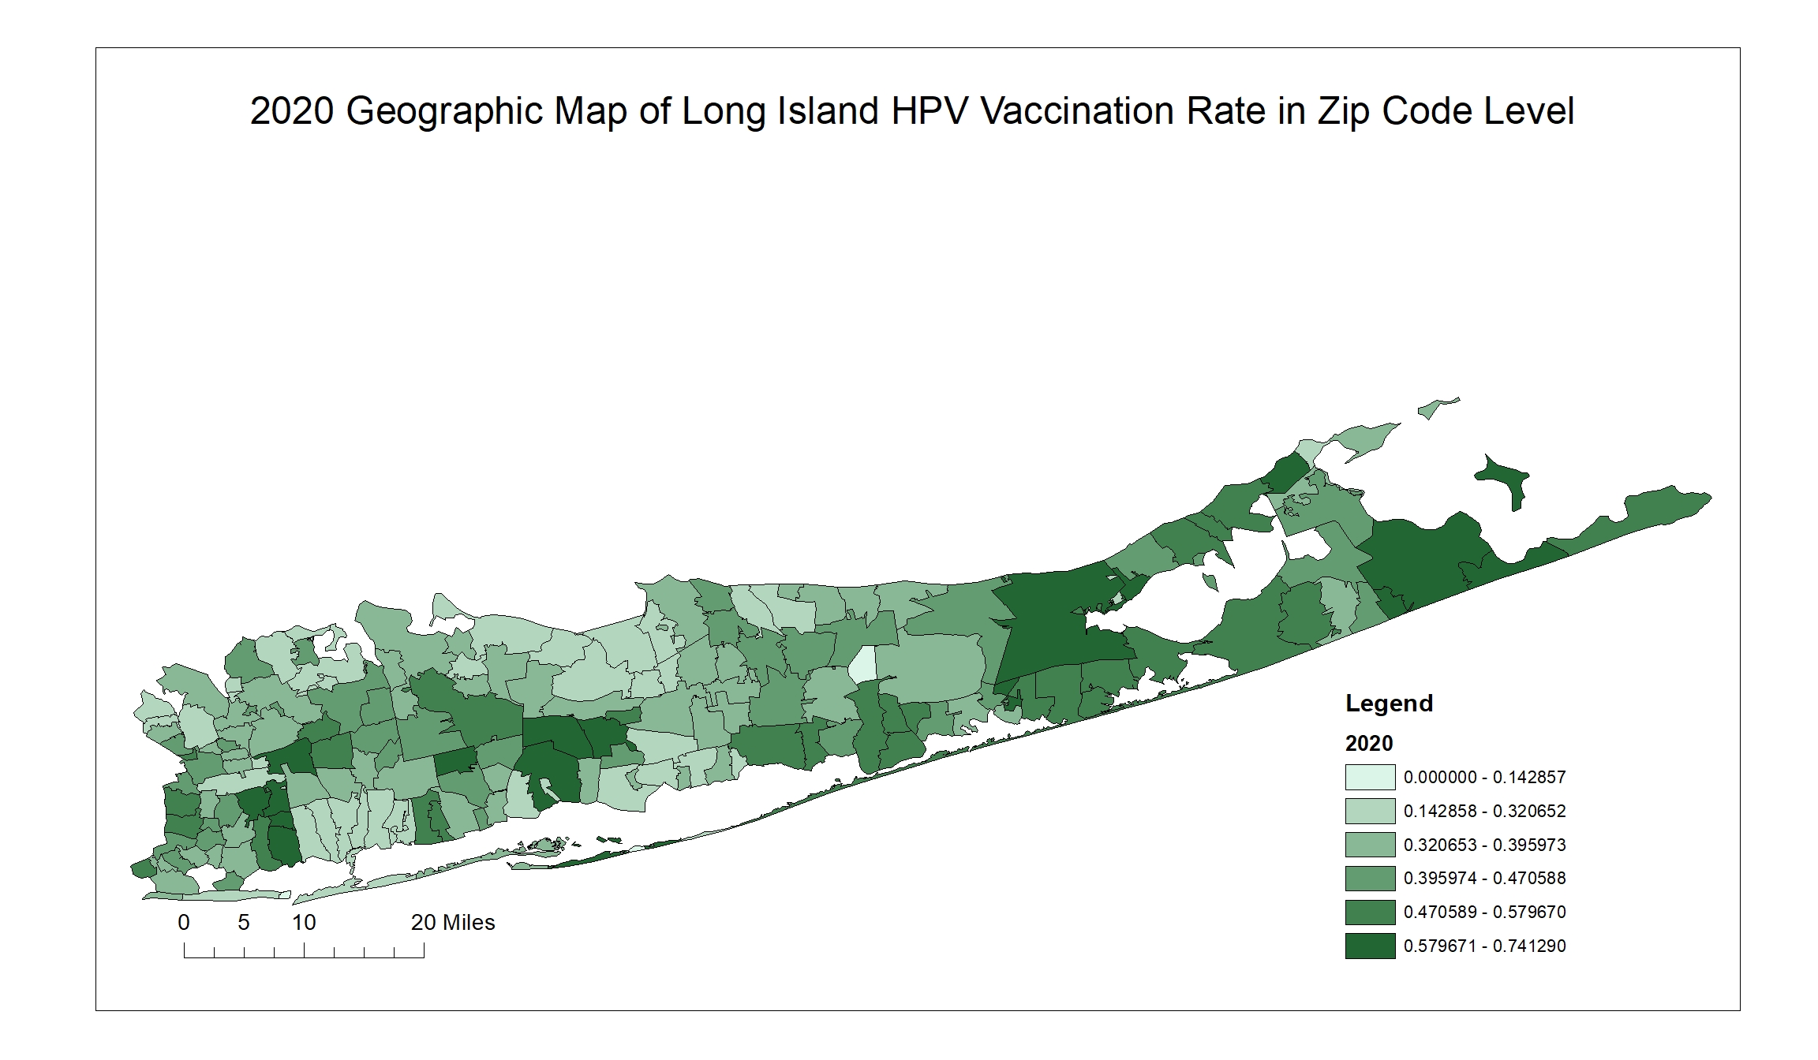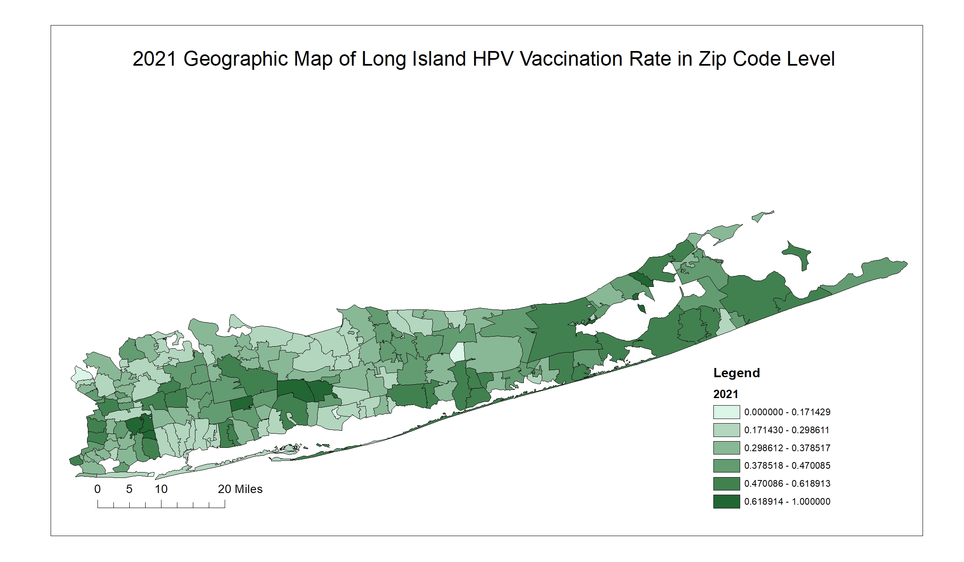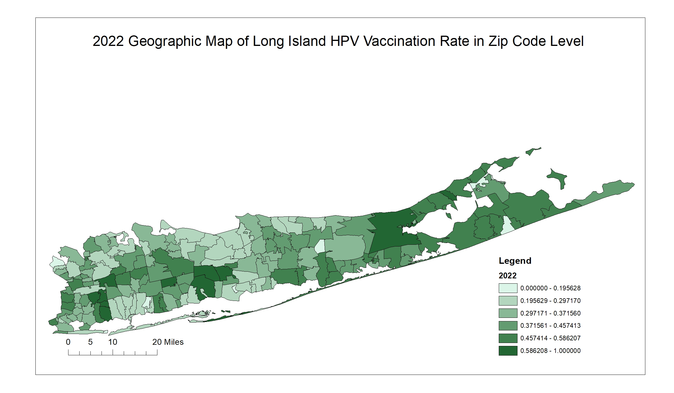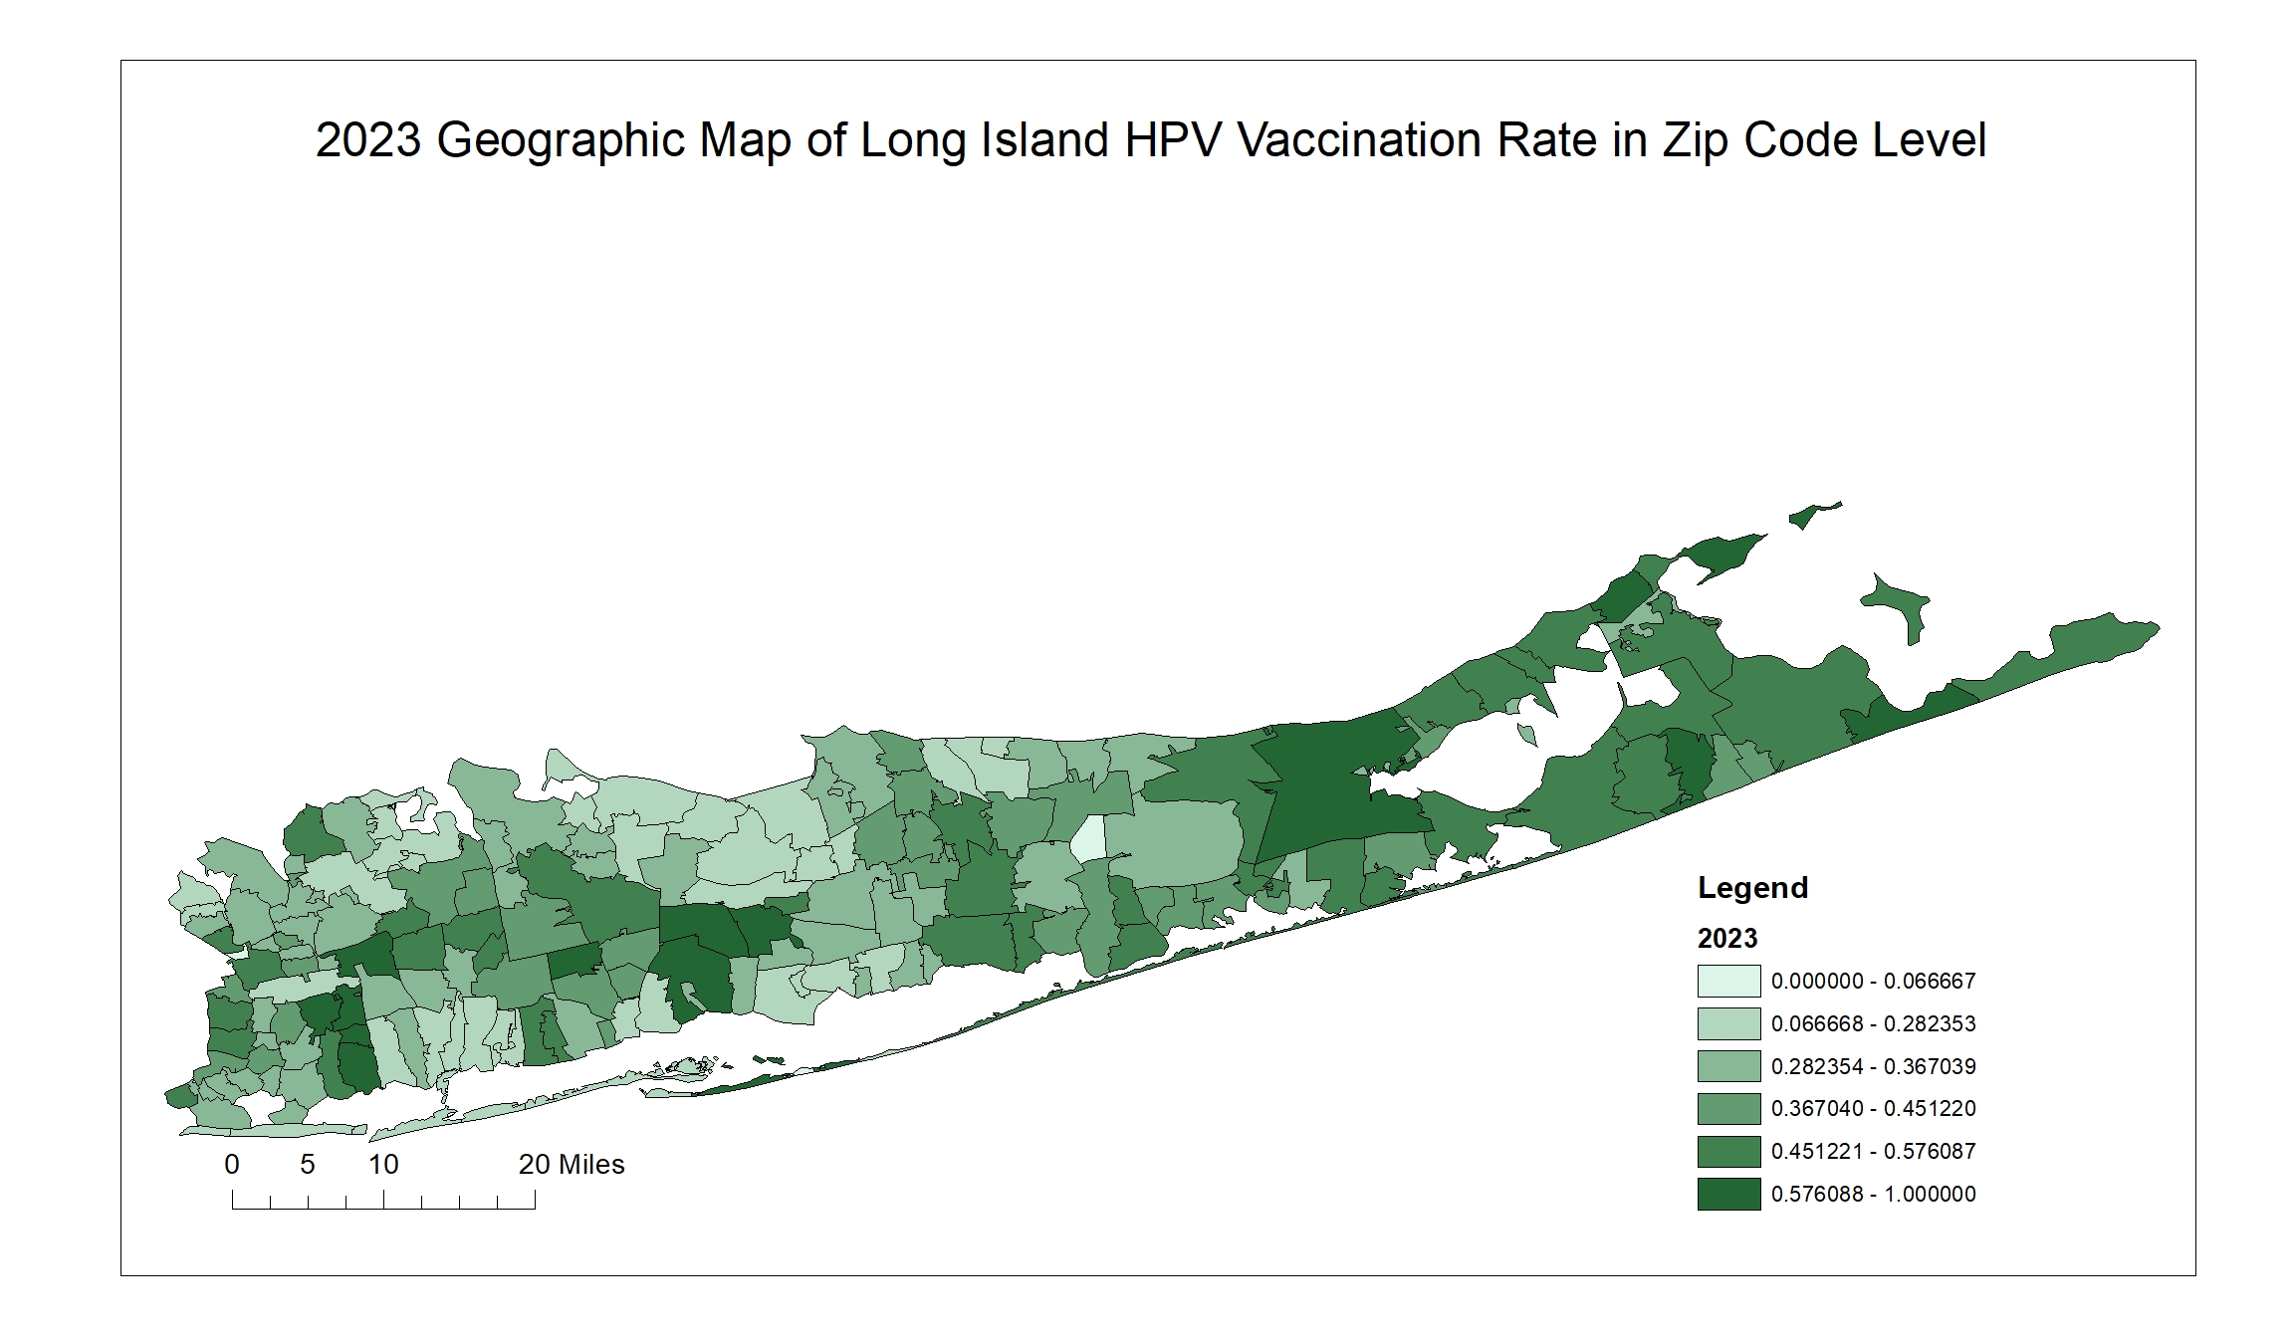

(A)

(B)

(C)

(D)

(E)

(F)

(G)

(H)